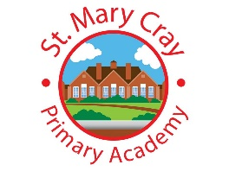
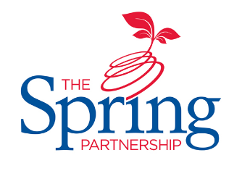
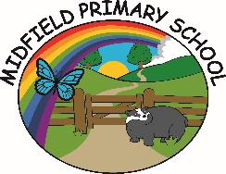
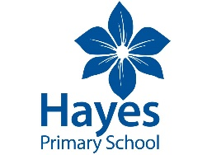
The Spring Partnership Trust

Home Learning Overview:
Year Group: 3 Week Beginning: Monday 23rd November
Subject | For week beginning:
 | - Resources needed | - Guidance (Part of home learning)
English | Oak Academy | Follow the link to 5 activities based around Exploring the Deep by Chloe Rodes.  https://classroom.thenational.academy/units/hidden-depths-exploring-the-deep-by-chloe-rodes-f720
Reading | Reading Book | Reading should happen daily for 30 minutes.
Spelling | Spelling Sets – on school website. | Your child should continue to learn the spellings from their clued spelling, spelling set.
Grammar | BBC Bitesize | https://www.bbc.co.uk/bitesize/topics/zwwp8mn Follow the link and write a definition with examples for all 11 learner guides.
Maths | Videos on the White Rose Maths website  Worksheets on our class page on the website. | https://whiterosemaths.com/homelearning/year-3  Follow the lessons on White Rose website. Watch the videos then complete the worksheets. All worksheets can be found on the class pages on the school website.
Times tables | PIXL App | Practice your times tables on the PIXL TT App
Science | BBC Bitesize | WALT: understand magnetic attraction  https://www.bbc.co.uk/bitesize/topics/zyttyrd Use the link to design a poster displaying all of you knowledge about magnets.
History | PPT | WALT: understand Lady Fu Hao  Please complete the comprehension on the school website.
Art/ D &T | Paints | 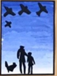  WALT: colour mix  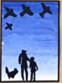  Experiment with colour mixing using paint. Using https://www.edvardmunch.org/, can you paint your own picture of Edvard Munch`s ‘Scream’.
PSHE | n/a | WALT: understand Bullying  - Please write a school policy to eradicate bullying.  - If you were a member of the anit-bullying squad, what 6 rules would you set out for all children at school to abide by.
Discovery RE | n/a | WALT: understand the relevance of Christmas  Research as many Christian charities as you can and design a fact-file explaining all about your 6 favourites.

