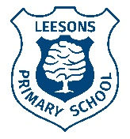
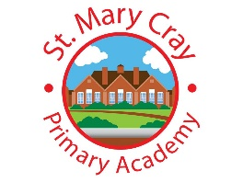
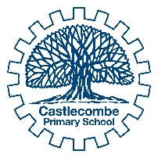
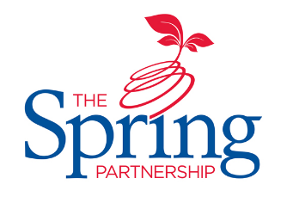
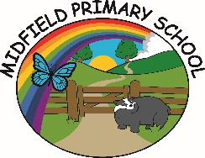
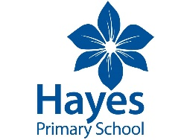
The Spring Partnership Trust

Home Learning Overview:
Year |Group: 4 Week Beginning: Monday 23rd November
Subject | For week beginning:
 | - Resources needed | - Guidance (Part of home learning)
English |  | Complete Comprehension and Create a leaflet task on Google Classroom.
Reading | Reading Book | Reading should happen daily for 15-20 minutes.
Spelling | Clued Spelling | Your child should continue to learn the spellings from their clued spelling set.
Grammar | Websites | Practise using the correct determiners – a, an and the. Then take the quiz on the second link.  https://www.turtlediary.com/game/identify-the-article.html  https://www.englishclub.com/grammar/determiners-quiz.htm
Maths | Videos on the White Rose Maths website | Follow the lessons on the White Rose website. Watch the videos then complete the worksheets which can be found on the school website.  https://resources.whiterosemaths.com/resources/year-4/autumn-block-3-length-perimeter/  Perimeter of a rectangle, Perimeter of rectilinear shapes and Kilometers
Times tables | Websites | Your child will know which times tables they are on and can use the following websites to help them practise:  https://www.timestables.co.uk/  https://www.mathsisfun.com/timestable.html  https://www.cgpbooks.co.uk/info/times-table-tester
Science | Zip-lock bag  Bread  Orange juice  BBC bitesize | WALT: understand what happens to food in our stomach.  - Give your child a zip-lock bag and a couple of crackers or piece of bread. The bag is like the stomach - a muscle that squeezes the food.  - Now pour a little orange juice or coke into the bag to act as the "digestive juices." Observe what begins to happen to the bread/cracker.  - Then squeeze the bag for two minutes. Note changes in the bread (it turns to liquid and is ready to be absorbed into the small intestine and into the blood stream).  Can they now draw what happened in their model and then use this to explain what happens in our stomachs?  They can use this video to help them explain: https://www.bbc.co.uk/bitesize/topics/z27kng8/articles/zg2g7p3  Once they have completed the task, they can take the quiz underneath the video.
History | BBC Bitesize | WALT: understand Viking beliefs.  Watch the video to find out about some of the things Vikings believed in: https://www.bbc.co.uk/bitesize/clips/zyy9wxs  Research a Norse God (Thor, Freya, Frey, Loki, Odin) of your choice and create a fact file.
Art/ D &T | Tate website  Paint and paintbrushes | WALT: express an emotion using the techniques of Jackson Pollock.  Learn about Jackson Pollock https://www.tate.org.uk/kids/explore/who-is/who-jackson-pollock  Use his techniques of spraying, splattering, pouring, and dripping to create artwork.
PSHE | BBC Bitesize  Youtube | WALT: understand what bullying is.  Learn what bullying is by watching this video:  https://www.bbc.co.uk/bitesize/clips/z7vnvcw  Explore the first three scenarios, discuss whether it is bullying or not and why. Then think about the person should do in that scenario.  https://www.youtube.com/watch?v=YFPIYdezysQ
Discovery RE |  | WALT: explore symbols in the Christmas nativity story.  Read the nativity story below and explore what symbols there are and what they represent.  https://www.topmarks.co.uk/christmas/nativitystory.aspx  The angel symbolises that Jesus was not just an ordinary man but a special gift from God. The incarnation of God.  The star guided the wise men just as Jesus is the light that guided people to God.  The wise men and the Shepherds are an interesting contrast between rich and poor, symbolising that Jesus is a gift to everyone.  The gifts from the wise men: gold is a precious metal symbolising how precious Jesus is and represents his Kingship. Frankincense is used in perfume and incense and represents Jesus’ priestly role. Myrrh is also used in perfumes and incense and in Jesus’ day was an embalming ointment which symbolises his death.  The manger and stable were humble beginnings for a ‘King’.

