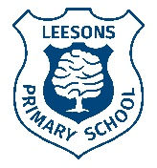
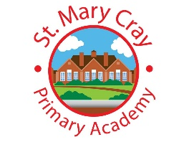
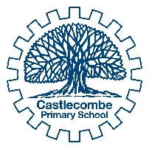
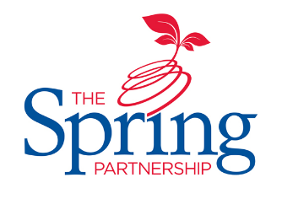
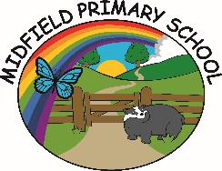
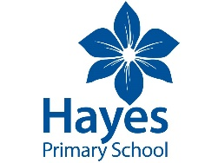
The Spring Partnership Trust

Home Learning Overview:
Year |Group: 3 Week Beginning: Monday 16th November
Subject | For week beginning:
 | - Resources needed | - Guidance (Part of home learning)
English | Oak Academy | https://classroom.thenational.academy/units/the-suitcase-kid-by-jacqueline-wilson-094b Follow the link to 5 activities based around the Suitcase Kid by Jaqueline Wilson
Reading | Reading Book | Reading should happen daily for 30 minutes.
Spelling | Spelling Sets – on school website. | Your child should continue to learn the spellings from their clued spelling, spelling set.
Grammar | BBC Bitesize | Watch the video about using the four sentence types https://www.bbc.co.uk/bitesize/articles/zvp6dp3 and complete the activities.
Maths | Videos on the White Rose Maths website  Worksheets on our class page on the website. | https://whiterosemaths.com/homelearning/year-3  Follow the lessons on White Rose website. Watch the videos then complete the worksheets. All worksheets can be found on the class pages on the school website.
Times tables | PIXL App | Practice your times tables on the PIXL TT App
Science | BBC Bitesize | WALT: understand the history of magnets  Please complete the comprehension on the school website
History | PPT | WALT understand Shang social structure:  https://paigeancientchina.weebly.com/social-structure.html Follow the link - the information provided is excellent, but the website out of date. The website makers have asked for your help to design a new pyramid that shows the social classes in the Shang Dynasty as a pyramid: they have requested that the pyramid has clear information as well as some drawings to keep the reader engaged. Good luck!
Art/ D &T | Paints | 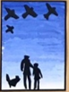  WALT: colour mix  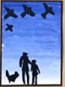  Experiment with colour mixing using paint. Using http://the-creative-business.com/10-sky-paintings-famous-artists/, can you paint a picture of the sky when it is sunny, and when it is overcast or raining?
PSHE | n/a | WALT: deal with conflict  Please find the ‘Solve it Together’ code poster on the school website. Can you design your own poster using these ideas that we can display in the classroom.
Discovery RE | n/a | WALT: understand the relevance of Christmas  Using the Christmas Knowledge Organiser, can you answer the questions sheet ‘Has Christmas lost its true meaning?` saved on the school website?

