Non-chronological report

Bats

Wherever you go in the world, apart from the polar regions and a few lonely islands, you will find bats. Yet, considering how widespread they are, these fascinating creatures are remarkably unfamiliar to many people. Maybe it’s their association with spooky stories, or maybe it’s simply the fact that most of them only appear at night that gives them their mysterious reputation. Whatever the reason, it’s time to dispel some of the myths.

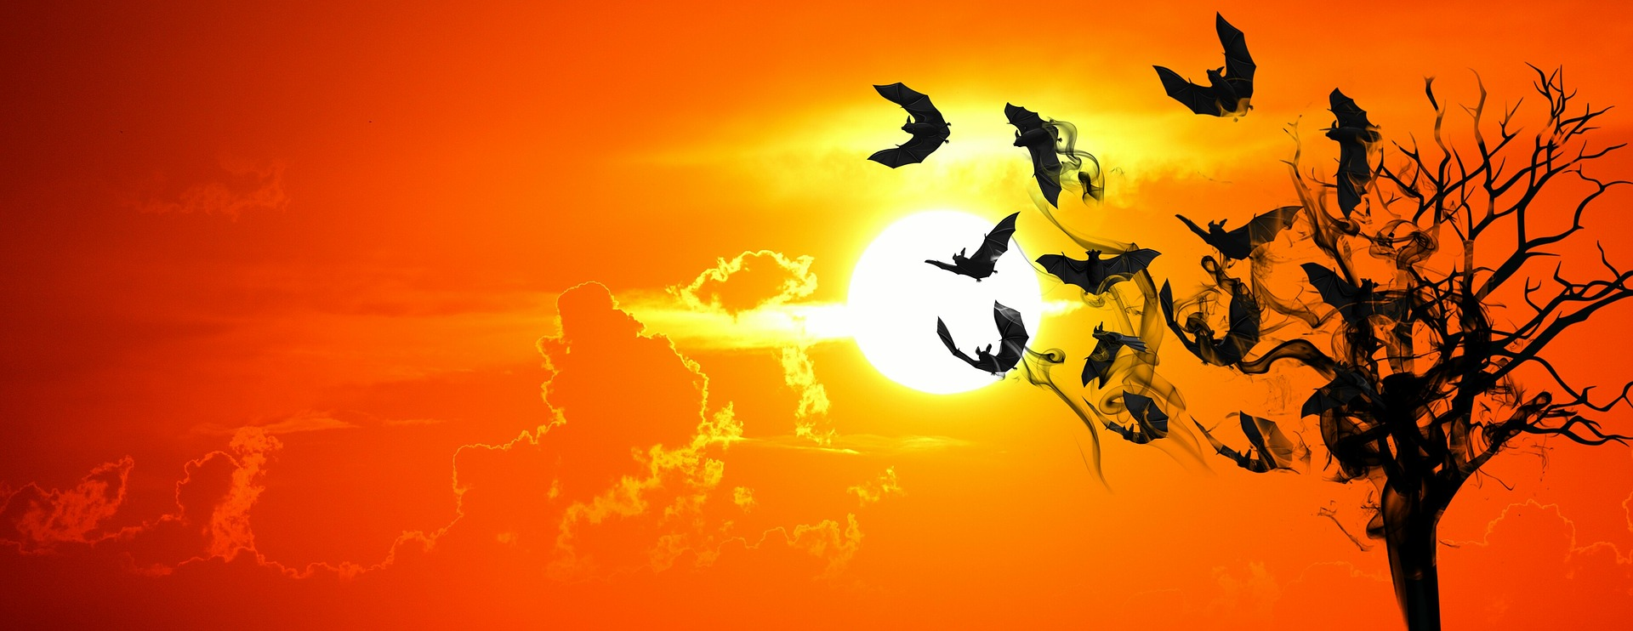

Flying mammals
‘Bat’ is the umbrella term for a whole set or ‘order’ of flying mammals. Indeed, bats are the only mammals that can really fly; species such as the flying squirrel can only glide once they have jumped off a high branch. Like birds, bats flap their wings in order to power their flight, but there is a big difference in the structure of their wings. Whereas birds have feathers sticking out from ‘arms’, bats have thin webbing stretched between their long fingers. As a result, birds are the more efficient fliers, but bats tend to be better at changing direction in mid-air.

Food
From fruit to fish and from bugs to blood, different bats favour a wide variety of foods. More than two thirds of all bat species eat insects. Often, they hunt them in mid-air by using echo-location, which means they make high-pitched noises and listen for the echo to pinpoint their prey. The largest bats, which are sometimes called flying foxes, feed on fruit – ripping them off trees and taking them back to their roosts. There, they hang up-side down from branches, sucking out the juice and spitting out the pips. Some bats suck nectar from flowers; others catch frogs and even fish. Perhaps the most notorious are vampire bats, which suck blood from large mammals such as cattle. But don’t worry; there are no vampire bats in the UK.

Breeding
Most bats only give birth to one baby at a time, but they might have as many as three in a year. For those that live in warmer (but not tropical) regions, the young tend to be born in the spring, but the general rule is that breeding happens when there is most food available. In fact, some bats are even able to delay getting pregnant in times of shortage. Being mammals, new-born bats drink their mother’s milk, but as soon as their wings are fully developed, they are expected to fly off and feed themselves.

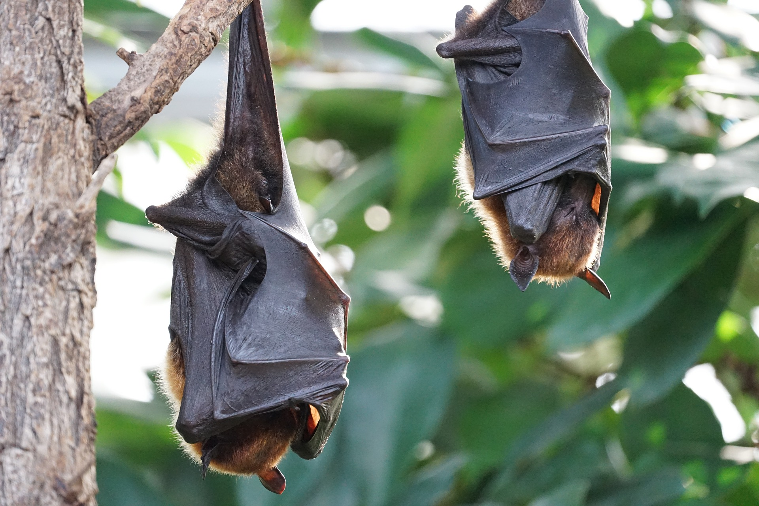

Living
Bats use different roosts for different activities. Some have special maternity roosts where they rear their young. Some migrate long distances to spend the winter in warmer climates. Some find a sheltered spot to hibernate throughout the colder months. Trees and caves have always been typical bat roosts, but more recently, some have been using manmade structures such as houses and churches as a place to call home.

Protection
Bats are not just fascinating – they’re useful too. A number of plant species rely on nectar-drinkers to help pollinate their flowers, or fruit bats to make sure their seeds are properly dispersed. Insectivores (bug-eaters) play an important part in maintaining nature’s balance by helping to control pests, with some of them eating thousands of insects each and every night. Little wonder, then, that many bats species are highly valued by humans and, here in the UK, they are protected by law. Why not play your part by finding out how you can create a bat-friendly roosting site at or near your home?

Bat Facts
- Bats don’t usually hunt insects in the rain because it interferes with their echo-location.
- Bats usually scoop up the bugs with their wings in mid-air, then take them home to eat.
- There are 18 different species of bat that can be found in the UK.
- Some bats have such good ears, they can hear a ladybird’s footsteps.
- Some bats can communicate, not just to whole populations, but to particular individuals that recognise slightly different call signs or ‘voices’.

